Robust clipped correlation: NZDUSD and USDCAD
Method 04 / daily log returns clipped at ±0.01, ±0.02, ±0.03 / Alpari D1 full available history

Study setup
Logical pair: NZDUSD , USDCAD
Broker symbols: NZDUSD_i , USDCAD_i
Snapshot: 2026-11-03_majors_alpari_D1
Timeframe: D1
Matched return window: 1999-01-05 to 2026-11-02 (UTC bar dates)
Matched return count n: 7190
Dropped unfinished last bar dated 2026-11-03 UTC after a tick-volume check against the prior complete day.
Clip bounds c in log-return units: 0.01, 0.02, 0.03 (about ±1%, ±2%, ±3% on the log scale). Headline c = 0.02.
Clipping caps a day's magnitude at ±c and keeps the row; it does not drop the day, so n is the same at every c.
Complete matched rows (Excel): NZDUSD-USDCAD_Clipped_D1.xlsx
Complete matched rows (HTML table): NZDUSD-USDCAD_Clipped_D1_data.html

Method carried forward
Each matched daily log return of close, ln(close_t / close_t-1), is clipped in the broker quote direction before Pearson correlation: x_tilde = min(c, max(-c, x)) and y_tilde = min(c, max(-c, y)), then rho_clip = Pearson(x_tilde, y_tilde) on the same rows as raw Pearson r. Quotes are not inverted. A day beyond ±c stays in the sample at the cap; n does not change. rho_clip is symmetric under swap of the two symbols. rho_clip = 0 means no straight-line link among the clipped values in this sample; it does not mean no link of any kind. The score is not a cause, not a lead, and not a trading signal. Daily rows are not independent draws, so the two-sided p-value and Fisher interval are reported and treated as secondary to rho_clip. Cap-hit counts (|log return| > c) flag how much of each leg was capped.

Raw Pearson on the same rows
Pearson r: -0.587831
Two-sided p-value: 0
Approximate 95% Fisher interval: [-0.602756, -0.572495]
This is the unclipped comparison required by the method. The headline score is rho_clip at c = 0.02 below.

Clipped results
n = 7190 at every c. Headline row is c = 0.02. Cap-hit count is the number of days with |log return| > c before clipping.
c | rho_clip | p | ci_low | ci_high | rho_minus_r | NZDUSD_cap_hits | USDCAD_cap_hits | NZDUSD_cap_share | USDCAD_cap_share
0.01 | -0.544739 | 0 | -0.56079246 | -0.52827538 | 0.043092596 | 1106 | 403 | 0.153825 | 0.05605
0.02 | -0.574013 | 0 | -0.58930858 | -0.55830525 | 0.013818645 | 142 | 32 | 0.01975 | 0.004451
0.03 | -0.58498 | 0 | -0.59998211 | -0.56956631 | 0.0028513866 | 24 | 3 | 0.003338 | 0.000417

Conclusion
Over 7190 matched daily log-return rows for NZDUSD and USDCAD (broker quote directions unchanged), headline robust clipped correlation at c=0.02 is -0.5740 (negative, moderate straight-line association among clipped values in this sample). Approximate 95% Fisher interval on the clipped series: [-0.5893, -0.5583]. Same-sample raw Pearson r is -0.5878 (rho_clip minus r = 0.0138). Sensitivity across the fixed grid: c=0.01 same sign; c=0.02 same sign; c=0.03 same sign. Two-sided p under the usual independent bivariate-normal model is 0; that model does not match linked daily FX returns, so treat p as secondary. This does not establish cause, lead-lag, or a lasting trading rule.

What to look at in this file next time
1) rho_clip at c = 0.02 versus raw Pearson r. 2) Whether c = 0.01 and c = 0.03 keep the same sign as 0.02. 3) Cap-hit counts before treating a large gap as settled. 4) The ±0.02 lines on the returns chart and the clip box on the scatter.

Charts
Daily closes

Daily log returns with +/- 0.02 clip lines
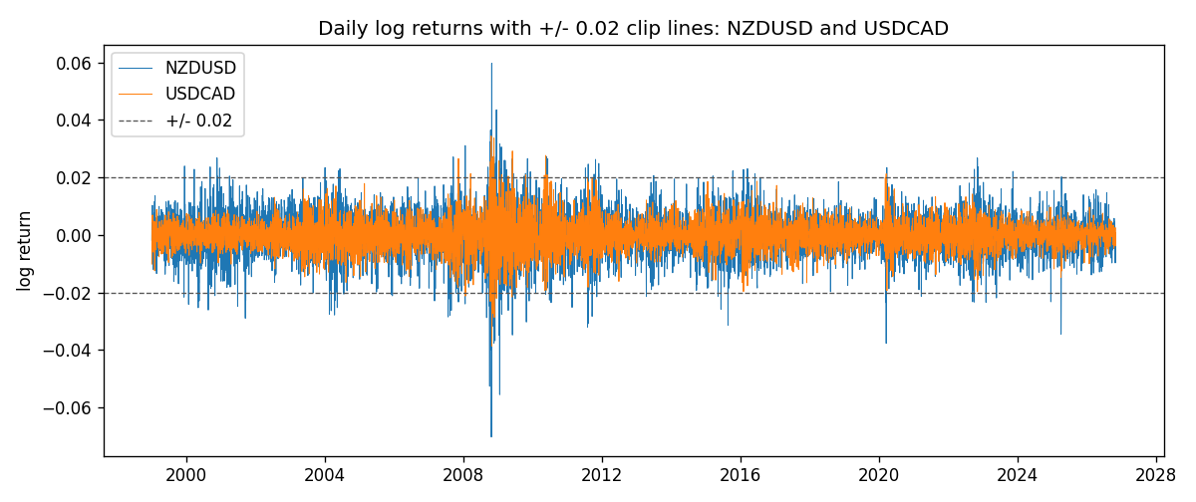
Log-return scatter with +/- 0.02 clip box
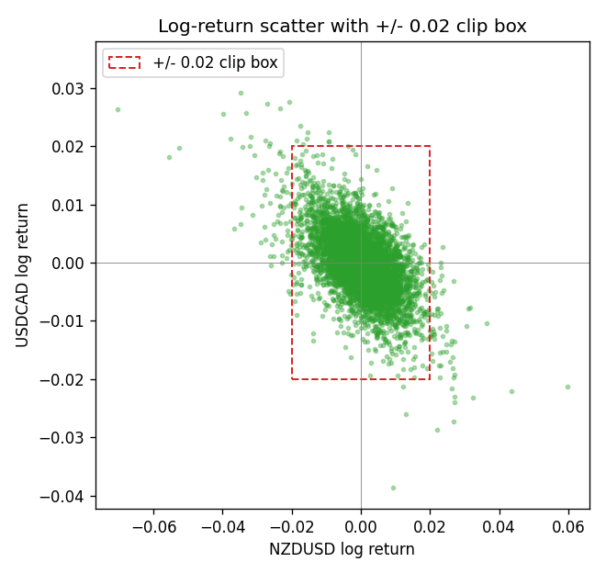

Data report
Every matched row that entered the clipped and raw correlations is stored in the sibling Excel workbook named NZDUSD-USDCAD_Clipped_D1.xlsx. That file is the complete data archive for redrawing charts. Embedding all rows as a Word table is impractical at this length; the Word file holds the column list, column summaries, and the first and last 15 matched rows.
Columns: time, NZDUSD_open, USDCAD_open, NZDUSD_high, USDCAD_high, NZDUSD_low, USDCAD_low, NZDUSD_close, USDCAD_close, NZDUSD_tick_volume, USDCAD_tick_volume, NZDUSD_spread, USDCAD_spread, NZDUSD_real_volume, USDCAD_real_volume, NZDUSD_log_return, USDCAD_log_return, NZDUSD_log_return_clip_0p01, USDCAD_log_return_clip_0p01, NZDUSD_log_return_clip_0p02, USDCAD_log_return_clip_0p02, NZDUSD_log_return_clip_0p03, USDCAD_log_return_clip_0p03
Column summaries (matched calculation rows)
column | count | mean | std | min | 25% | 50% | 75% | max
NZDUSD_open | 7190 | 0.6563919 | 0.10821436 | 0.3913 | 0.5912925 | 0.6684 | 0.7249075 | 0.88218
USDCAD_open | 7190 | 1.2668559 | 0.16897553 | 0.9168 | 1.118445 | 1.298545 | 1.37213 | 1.6183
NZDUSD_high | 7190 | 0.66030697 | 0.10871111 | 0.3961 | 0.5947025 | 0.67202 | 0.72936 | 0.88421
USDCAD_high | 7190 | 1.2717549 | 0.16892987 | 0.9336 | 1.122975 | 1.30394 | 1.37655 | 1.619
NZDUSD_low | 7190 | 0.65270307 | 0.10781082 | 0.3897 | 0.5880525 | 0.664185 | 0.720965 | 0.87988
USDCAD_low | 7190 | 1.2623003 | 0.16901312 | 0.9056 | 1.114125 | 1.293585 | 1.36785 | 1.6102
NZDUSD_close | 7190 | 0.65646372 | 0.10821182 | 0.3907 | 0.5915625 | 0.66842 | 0.725015 | 0.8822
USDCAD_close | 7190 | 1.266877 | 0.16895077 | 0.916 | 1.118165 | 1.298615 | 1.372425 | 1.6137
NZDUSD_tick_volume | 7190 | 68672.777 | 123109.57 | 16 | 5561.25 | 33864.5 | 58508 | 1127682
USDCAD_tick_volume | 7190 | 80995.8 | 147287.89 | 37 | 5534 | 40938 | 71622.5 | 1410818
NZDUSD_spread | 7190 | 30.299444 | 25.655426 | 0 | 9 | 17 | 50 | 80
USDCAD_spread | 7190 | 23.448679 | 18.267866 | 0 | 9 | 17 | 40 | 60
NZDUSD_real_volume | 7190 | 1.6692087e+10 | 8.4955308e+10 | 0 | 0 | 0 | 0 | 2.705649e+12
USDCAD_real_volume | 7190 | 1.8371592e+10 | 9.6675129e+10 | 0 | 0 | 0 | 0 | 2.5751613e+12
NZDUSD_log_return | 7190 | 6.02e-06 | 0.00764513 | -0.07027433 | -0.00425619 | 0.00022347 | 0.00457637 | 0.05966839
USDCAD_log_return | 7190 | -9.38e-06 | 0.0051433 | -0.03859748 | -0.00283202 | 5.381e-05 | 0.00272817 | 0.03436319
NZDUSD_log_return_clip_0p01 | 7190 | 0.00010185 | 0.00591139 | -0.01 | -0.00425619 | 0.00022347 | 0.00457637 | 0.01
USDCAD_log_return_clip_0p01 | 7190 | -2.929e-05 | 0.00449643 | -0.01 | -0.00283202 | 5.381e-05 | 0.00272817 | 0.01
NZDUSD_log_return_clip_0p02 | 7190 | 4.076e-05 | 0.0072031 | -0.02 | -0.00425619 | 0.00022347 | 0.00457637 | 0.02
USDCAD_log_return_clip_0p02 | 7190 | -1.434e-05 | 0.00504374 | -0.02 | -0.00283202 | 5.381e-05 | 0.00272817 | 0.02
NZDUSD_log_return_clip_0p03 | 7190 | 1.893e-05 | 0.00749374 | -0.03 | -0.00425619 | 0.00022347 | 0.00457637 | 0.03
USDCAD_log_return_clip_0p03 | 7190 | -9.3e-06 | 0.00512836 | -0.03 | -0.00283202 | 5.381e-05 | 0.00272817 | 0.03
First 15 matched rows (selected columns)
time | NZDUSD_close | USDCAD_close | NZDUSD_log_return | USDCAD_log_return | NZDUSD_log_return_clip_0p02 | USDCAD_log_return_clip_0p02
1999-01-05 | 0.5372 | 1.5123 | -0.0018597736 | -0.010131666 | -0.0018597736 | -0.010131666
1999-01-06 | 0.5383 | 1.5118 | 0.0020455609 | -0.0003306769 | 0.0020455609 | -0.0003306769
1999-01-07 | 0.5417 | 1.5141 | 0.0062963171 | 0.0015202092 | 0.0062963171 | 0.0015202092
1999-01-08 | 0.5414 | 1.511 | -0.00055396548 | -0.0020495197 | -0.00055396548 | -0.0020495197
1999-01-11 | 0.547 | 1.5057 | 0.010290425 | -0.0035137769 | 0.010290425 | -0.0035137769
1999-01-12 | 0.5441 | 1.5157 | -0.0053157489 | 0.0066194721 | -0.0053157489 | 0.0066194721
1999-01-13 | 0.5387 | 1.5226 | -0.0099742238 | 0.0045420214 | -0.0099742238 | 0.0045420214
1999-01-14 | 0.5386 | 1.5332 | -0.00018564931 | 0.0069376546 | -0.00018564931 | 0.0069376546
1999-01-15 | 0.5382 | 1.5245 | -0.00074294208 | -0.0056905671 | -0.00074294208 | -0.0056905671
1999-01-18 | 0.5372 | 1.526 | -0.0018597736 | 0.00098344542 | -0.0018597736 | 0.00098344542
1999-01-19 | 0.5382 | 1.5302 | 0.0018597736 | 0.002748513 | 0.0018597736 | 0.002748513
1999-01-20 | 0.5404 | 1.5211 | 0.0040793678 | -0.0059646885 | 0.0040793678 | -0.0059646885
1999-01-21 | 0.5426 | 1.5146 | 0.0040627941 | -0.0042823796 | 0.0040627941 | -0.0042823796
1999-01-22 | 0.5361 | 1.5184 | -0.012051689 | 0.0025057712 | -0.012051689 | 0.0025057712
1999-01-25 | 0.5342 | 1.5197 | -0.0035504102 | 0.00085579808 | -0.0035504102 | 0.00085579808
Last 15 matched rows (selected columns)
time | NZDUSD_close | USDCAD_close | NZDUSD_log_return | USDCAD_log_return | NZDUSD_log_return_clip_0p02 | USDCAD_log_return_clip_0p02
2026-10-13 | 0.56127 | 1.4214 | 0.0047326165 | -0.0046395653 | 0.0047326165 | -0.0046395653
2026-10-14 | 0.55918 | 1.42356 | -0.0037306483 | 0.0015184751 | -0.0037306483 | 0.0015184751
2026-10-15 | 0.56185 | 1.41843 | 0.0047634855 | -0.0036101503 | 0.0047634855 | -0.0036101503
2026-10-16 | 0.56509 | 1.41357 | 0.0057501001 | -0.0034322068 | 0.0057501001 | -0.0034322068
2026-10-19 | 0.56616 | 1.41091 | 0.0018917133 | -0.0018835331 | 0.0018917133 | -0.0018835331
2026-10-20 | 0.56827 | 1.40569 | 0.0037199341 | -0.0037066008 | 0.0037199341 | -0.0037066008
2026-10-21 | 0.57003 | 1.4045 | 0.0030923331 | -0.00084691787 | 0.0030923331 | -0.00084691787
2026-10-22 | 0.56815 | 1.40081 | -0.0033035227 | -0.0026307268 | -0.0033035227 | -0.0026307268
2026-10-23 | 0.56991 | 1.40085 | 0.0030929853 | 2.85545e-05 | 0.0030929853 | 2.85545e-05
2026-10-26 | 0.56826 | 1.40093 | -0.0028993932 | 5.7106554e-05 | -0.0028993932 | 5.7106554e-05
2026-10-27 | 0.56811 | 1.40449 | -0.00026399852 | 0.0025379458 | -0.00026399852 | 0.0025379458
2026-10-28 | 0.56261 | 1.39911 | -0.0097283914 | -0.0038379274 | -0.0097283914 | -0.0038379274
2026-10-29 | 0.56296 | 1.39895 | 0.00062190714 | -0.00011436495 | 0.00062190714 | -0.00011436495
2026-10-30 | 0.56307 | 1.39751 | 0.00019537668 | -0.0010298736 | 0.00019537668 | -0.0010298736
2026-11-02 | 0.56161 | 1.39837 | -0.0025962955 | 0.00061519094 | -0.0025962955 | 0.00061519094

